MACHINE LEARNING LAB
CYCLE 4

1.Using the iris data set implement the KNN algorithm. Take different values for Test and training
data set .Also use different values for k. Also find the accuracy level.

CODE

import numpy as np
import matplotlib.pyplot as plt
import pandas as pd
from sklearn.model_selection import train_test_split
from sklearn.neighbors import KNeighborsClassifier

from sklearn.metrics import accuracy_score

dataset = pd.read_csv("iris.csv")
X = dataset.iloc[:, :-1].values
y = dataset.iloc[:, 4].values

X_train, X_test, y_train, y_test = train_test_split(X, y, test_size=0.20)

classifier = KNeighborsClassifier(n_neighbors=50)
classifier.fit(X_train, y_train)
y_pred = classifier.predict(X_test)

accuracy = accuracy_score(y_test,y_pred)
print("Accuracy :",accuracy)

for(i,j) in zip(y_pred,y_test):
if i != j:
print("actual value:",i,"\npredicted value :",j)
print("Number of mislabeled points from test data set :",(y_test != y_pred).sum())

OUTPUT
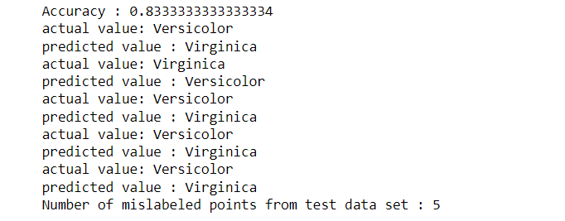

2.Download another data set suitable for the KNN and implement the KNN algorithm. Take different
values for Test and training data set .Also use different values for k.

CODE

import numpy as np
import matplotlib.pyplot as plt
import pandas as pd
dataset = pd.read_csv("breastcancer.csv")
# dataset.head()
# dataset.info()
x = dataset.iloc[:, :-1].values
print(x)
y = dataset.iloc[:, 4].values
print(y)
from sklearn.model_selection import train_test_split
X_train, X_test, y_train, y_test = train_test_split(x, y, test_size=0.20)
from sklearn.neighbors import KNeighborsClassifier
classifier = KNeighborsClassifier(n_neighbors=5)
classifier.fit(X_train, y_train)
y_pred = classifier.predict(X_test)
from sklearn.metrics import classification_report, confusion_matrix
# print(classification_report(y_test, y_pred))
from sklearn.metrics import accuracy_score
print ("Accuracy : ", accuracy_score(y_test, y_pred))
# df = pd.DataFrame({'Real Values':y_test, 'Predicted Values':y_pred})
# df
for(i,j) in zip(y_pred,y_test):
if i != j:
print("actual value:",i,"\npredicted value :",j)
print("Number of mislabeled points from test data set :",(y_test != y_pred).sum())

OUTPUT
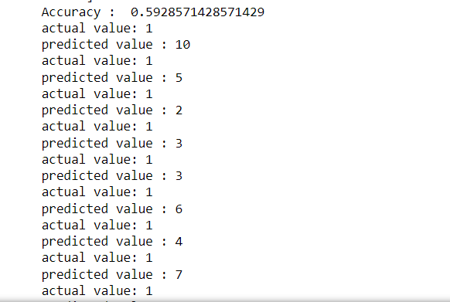

3.

i)CODE(GAUSSIAN)

import numpy as np
import matplotlib.pyplot as plt
import pandas as pd
dataset = pd.read_csv('iris.csv')
X = dataset.iloc[:,:4].values
y = dataset['variety'].values
dataset.head(5)
from sklearn.model_selection import train_test_split
X_train, X_test, y_train, y_test = train_test_split(X, y, test_size = 0.2)
from sklearn.naive_bayes import GaussianNB
classifier = GaussianNB()
classifier.fit(X_train, y_train)
y_pred = classifier.predict(X_test)
y_pred
from sklearn.metrics import confusion_matrix
cm = confusion_matrix(y_test, y_pred)
from sklearn.metrics import accuracy_score
print ("Accuracy : ", accuracy_score(y_test, y_pred))
cm
for(i,j) in zip(y_pred,y_test):
if i != j:
print("actual value:",i,"\npredicted value :",j)
print("Number of mislabeled points from test data set :",(y_test != y_pred).sum())

OUTPUT
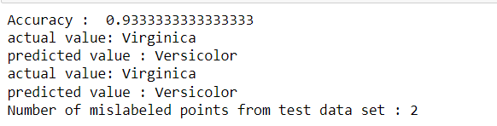

ii)CODE(Bernoulli)

import numpy as np
import matplotlib.pyplot as plt
import pandas as pd
dataset = pd.read_csv('iris.csv')
X = dataset.iloc[:,:4].values
y = dataset['variety'].values
dataset.head(5)
from sklearn.model_selection import train_test_split
X_train, X_test, y_train, y_test = train_test_split(X, y, test_size = 0.2)
from sklearn.naive_bayes import BernoulliNB
classifier = BernoulliNB()
classifier.fit(X_train, y_train)
y_pred = classifier.predict(X_test)
y_pred
#from sklearn.metrics import confusion_matrix
#cm = confusion_matrix(y_test, y_pred)
from sklearn.metrics import accuracy_score
print ("Accuracy : ", accuracy_score(y_test, y_pred))
for(i,j) in zip(y_pred,y_test):
if i != j:
print("actual value:",i,"\npredicted value :",j)
print("Number of mislabeled points from test data set :",(y_test != y_pred).sum())

OUTPUT
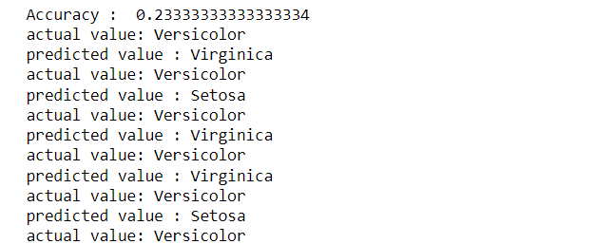

4. Use car details CSV file and implement decision tree algorithm
• Find out the accuracy level.
• Display the no:of mislabeled classification from test data set
• List out the class labels of the mismatching records

import os
import numpy as np
import pandas as pd
import numpy as np, pandas as pd
import matplotlib.pyplot as plt
from sklearn import tree, metrics, model_selection

data = pd.read_csv('car.csv',names=['buying','maint','doors','persons','lug_boot','safety','class'])
data.head()
data.info()

data['class'],class_names = pd.factorize(data['class'])

print(class_names)
print(data['class'].unique())

data['buying'],_ = pd.factorize(data['buying'])
data['maint'],_ = pd.factorize(data['maint'])
data['doors'],_ = pd.factorize(data['doors'])
data['persons'],_ = pd.factorize(data['persons'])
data['lug_boot'],_ = pd.factorize(data['lug_boot'])
data['safety'],_ = pd.factorize(data['safety'])
data.head()
data.info()
X = data.iloc[:,:-1]
y = data.iloc[:,-1]

# split data randomly into 70% training and 30% test
X_train, X_test, y_train, y_test = model_selection.train_test_split(X, y, test_size=0.3, random_state=0)

# train the decision tree
dtree = tree.DecisionTreeClassifier(criterion='entropy', max_depth=3, random_state=0)
dtree.fit(X_train, y_train)
# use the model to make predictions with the test data
y_pred = dtree.predict(X_test)
# how did our model perform?
accuracy = metrics.accuracy_score(y_test, y_pred)
print('Accuracy: {:.2f}'.format(accuracy))
count_misclassified = (y_test != y_pred).sum()
print('Misclassified samples: {}'.format(count_misclassified))

OUTPUT

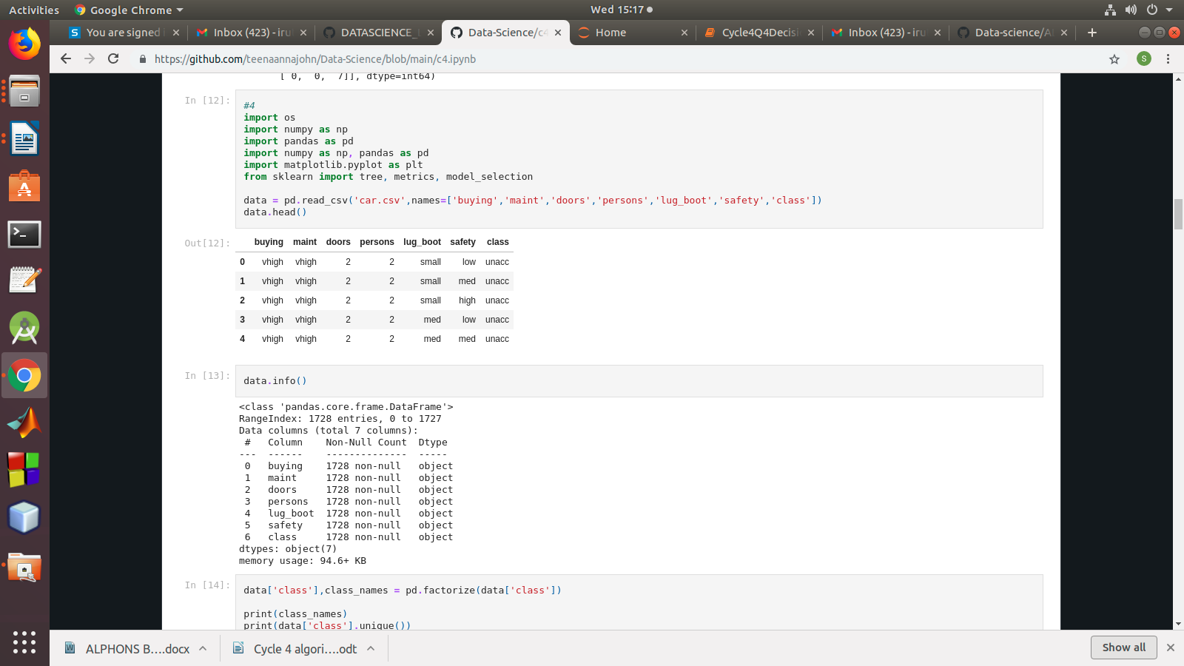

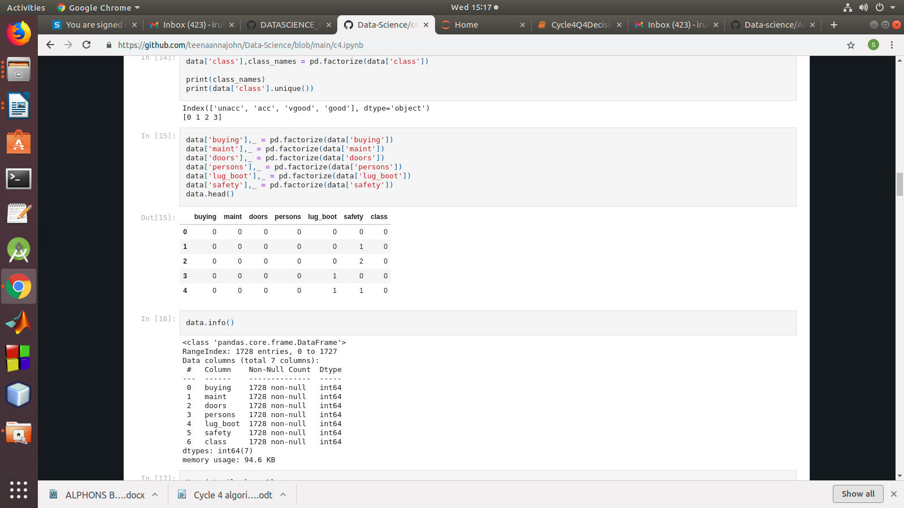

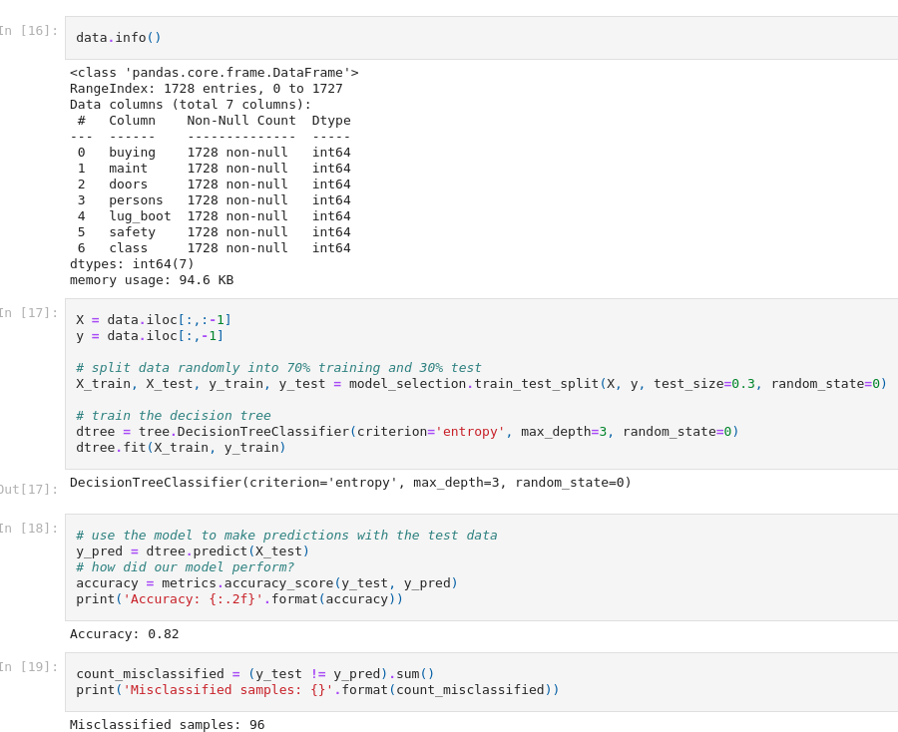

5.Implement Simple and multiple linear regression for the data sets ‘student_score.csv’ and ‘company_data .csv’ respectively

Implement Simple and multiple linear regression for the data sets ‘student_score.csv’
# and ‘company_data .csv’ respectively.

import numpy as np
import pandas as pd
import matplotlib.pyplot as plt

#data set contains details of no.of hours spend by students for studt and their marks
student = pd.read_csv('student_scores.csv')
student.head()
student.describe()

student.info()
import matplotlib.pyplot as plt

Xax=student.iloc[:,0]
Yax=student.iloc[:,1]
plt.scatter(Xax,Yax)
plt.xlabel("No.of hours")
plt.ylabel("Score")
plt.title("Student scores")
plt.show()
#Perform the simple linear regression model
#Equation: Y=w0+w1.x
#Here Y(marks)=w0+w1.x
#Create x as hours and Y as marks

X = student.iloc[:, :-1]
y = student.iloc[:, 1]
print(X)
print(y)

from sklearn.model_selection import train_test_split
X_train, X_test, y_train, y_test = train_test_split(X, y, test_size=0.2)
print(X_train)
from sklearn.linear_model import LinearRegression
regressor = LinearRegression()
regressor.fit(X_train, y_train)
print(regressor.intercept_)
print(regressor.coef_)
y_pred = regressor.predict(X_test)
for(i,j) in zip(y_test,y_pred):
if i!=j:
print("Actual value :",i,"Predicted value :",j)
print("Number of mislabeled points from test data set :", (y_test != y_pred).sum())
from sklearn import metrics
print("Mean Absolute error :", metrics.mean_absolute_error(y_test,y_pred))
print("Mean Squared error :", metrics.mean_squared_error(y_test,y_pred))
print("Root Mean Squared error :", np.sqrt(metrics.mean_squared_error(y_test,y_pred)))
import matplotlib.pyplot as plt
c=X_test['Hours'].count()
xax=np.arange(c)
print(xax)
X_axis = np.arange(len(xax))
plt.bar(X_axis-0.2, y_test, 0.6, label='Actual')
plt.bar(X_axis+0.2, y_pred, 0.6, label='Predicted')

plt.xlabel("Test Records")
plt.ylabel("Marks")
plt.title("Student Score prediction")
plt.legend()
plt.show()

OUTPUT

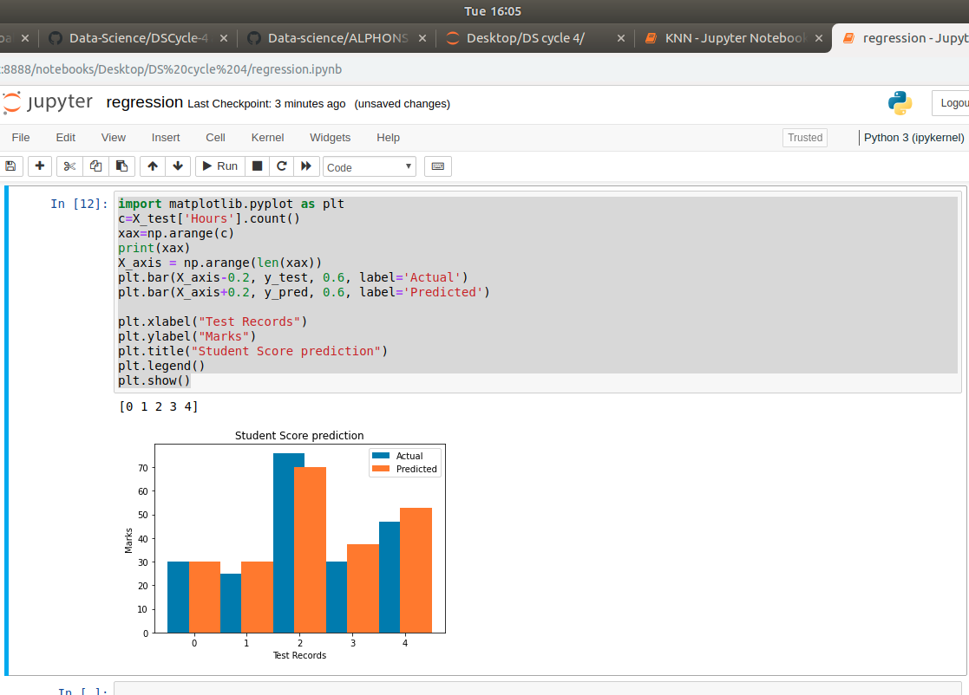

6.multiple linear regression for the data sets ‘student_score.csv’ and ‘company_data .csv’ respectively

import pandas as pd
import numpy as np
import matplotlib.pyplot as plt
advertising = pd.read_csv('Company_data.csv')
advertising.head()
advertising.describe()
Out[2]:
advertising.info()

import matplotlib.pyplot as plt
import seaborn as sns
sns.pairplot(advertising, x_vars=['TV', 'Radio', 'Newspaper'],
y_vars='Sales', height=5, aspect=1, kind='scatter')
plt.show()

#perform the multiple linear regression model
#Equation : Y=w0+w1.x1 + w2.x2 + w3.x3
#Here Y(sales)=w0+w1.x1(TV)+w2.x2(Radio)+w3.x3(Newspaper)
#create x and Y as sales

X = advertising.iloc[:, :-1]
print(X)
y = advertising.iloc[:, -1]
print(y)
from sklearn.model_selection import train_test_split
X_train, X_test, y_train, y_test = train_test_split(X, y, test_size=0.3)
print(X_train)
from sklearn.linear_model import LinearRegression
regressor = LinearRegression()
regressor.fit(X_train, y_train)
print(regressor.intercept_)
print(regressor.coef_)
y_pred = regressor.predict(X_test)
for(i,j) in zip(y_test,y_pred):
if i!=j:
print("Actual value :",i,"Predicted value :",j)
print("Number of mislabeled points from test data set :", (y_test != y_pred).sum())
from sklearn import metrics
print("Mean Absolute error :", metrics.mean_absolute_error(y_test,y_pred))
print("Mean Squared error :", metrics.mean_squared_error(y_test,y_pred))
print("Root Mean Squared error :", np.sqrt(metrics.mean_squared_error(y_test,y_pred)))
import matplotlib.pyplot as plt
c=X_test['TV'].count()
xax=np.arange(c)
print(xax)
X_axis = np.arange(len(xax))
plt.bar(X_axis-0.2, y_test, 0.6, label='Actual')
plt.bar(X_axis+0.2, y_pred, 0.6, label='Predicted')

plt.xlabel("Sales")
plt.ylabel("Actual/Predicted")
plt.title("Sales prediction")
plt.legend()
plt.show()

OUTPUT

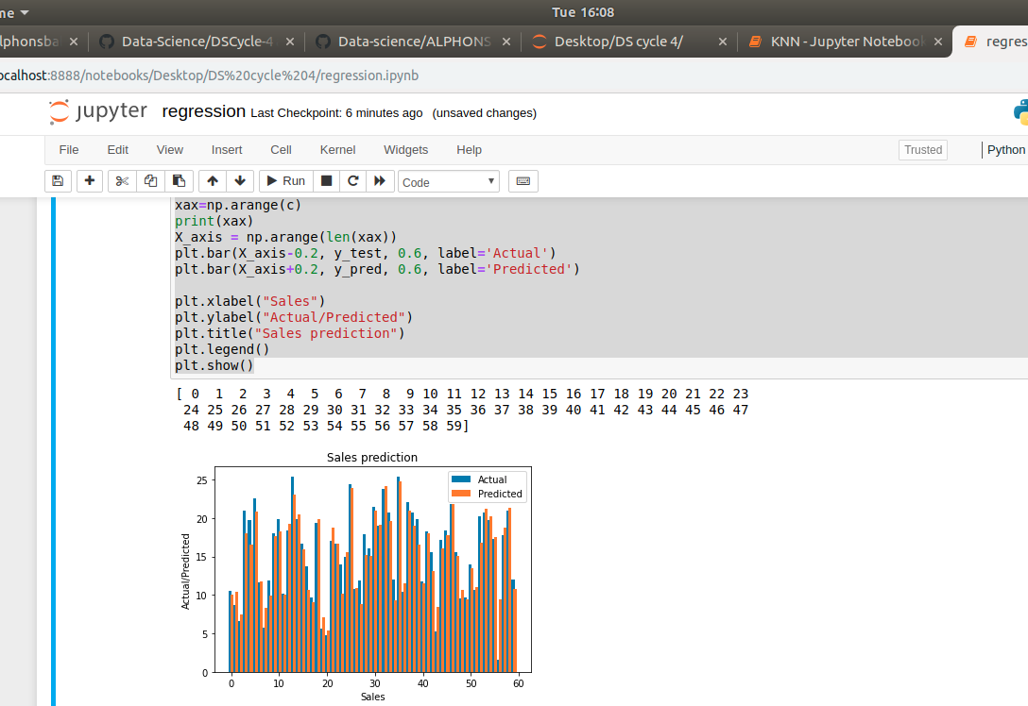

Neural Network
1.Create a neural network for the given ‘houseprice.csv’ to predict the whether
price of the house is above or below medianvalue or not

import pandas as pd
df = pd.read_csv('housepricedata.csv')
df
dataset = df.values
dataset
X = dataset[:,0:10]
Y = dataset[:,10]
from sklearn import preprocessing

min_max_scaler = preprocessing.MinMaxScaler()
X_scale = min_max_scaler.fit_transform(X)
X_scale
from sklearn.model_selection import train_test_split

X_train, X_val_and_test, Y_train, Y_val_and_test = train_test_split(X_scale, Y, test_size=0.3)
X_val, X_test, Y_val, Y_test = train_test_split(X_val_and_test, Y_val_and_test, test_size=0.5)
print(X_train.shape, X_val.shape, X_test.shape, Y_train.shape, Y_val.shape, Y_test.shape)

from keras.models import Sequential
from keras.layers import Dense

model = Sequential([
Dense(32, activation='relu', input_shape=(10,)),
Dense(32, activation='relu'),
Dense(1, activation='sigmoid'),
])

model.compile(optimizer='sgd',
loss='binary_crossentropy',
metrics=['accuracy'])
hist = model.fit(X_train, Y_train,
batch_size=32, epochs=100,
validation_data=(X_val, Y_val))

model.evaluate(X_test, Y_test)[1]

OUTPUT

